Title: **Watts Law Calculations** Worksheet: 3

Course: Electrical Applications Unit: Electrical Theory CLO: 3

Name ____________________________ Grade _______ Date ______________

**Objectives**

1. Student shall calculate power, current and voltage when given two of the three properties.
2. Student shall contrast the difference between power, current and voltage.

**Assessment**

Students shall demonstrate a comprehension of the objectives listed above by scoring a minimum of 75% on this Worksheet. Grading shall be based on an answer key.

**Conventions**

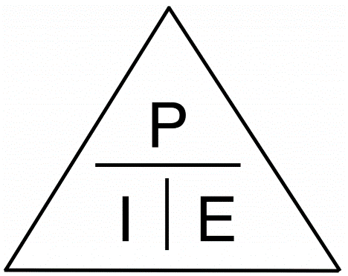

$$P=I x E, I= \frac{P}{E} , E= \frac{P}{I}$$

Where;

P = Power in Watts (W)

I = Current in Amperes (A)

E = Voltage in Volts (V)

**Instructions**

All answers will be in engineering units M, k, m, and μ. Answers will NOT be in powers of 10. Display at least 1 whole number and not more than 3 whole numbers to the left of the decimal, and round off to 3 decimal places to the right of the decimal.

1. P = 33W I = 725.807mA E = _______________
2. P = 12W I = _______________ E = 62V
3. P = 10mW I = _______________ E = 10V
4. P = _______________ I = 66mA E = 104V
5. P = 4W I = _______________ E = 40V
6. P = 512.312mW I = _______________ E = 17V
7. P = 6.2μW I = 55mA E = _______________
8. P = 75W I = _______________ E = 75V
9. P = _______________ I = 77mA E = 120V
10. P = _______________ I = 15mA E = 43mV
11. The circuit current is 80mA and the power dissipated by the circuit is 19.2W.  
    What is the source voltage?
12. The source voltage is 10V and the circuit current is 4mA.  
    What is the power dissipated by the circuit?
13. The source voltage is 15V and the circuit current is 55mA.  
    What is the power dissipated by the circuit?
14. The power dissipated by the circuit is 250mW and the source voltage is 3.2V.  
    What is the circuit current?
15. The power dissipated by the circuit is 300mW and the circuit current is 720mA.  
    What is the source voltage?
16. The power dissipated by the circuit is 600mW and the circuit current is 720mA.  
    What is the source voltage?
17. The power dissipated by the circuit is 400mW and the source voltage is 6.4V.  
    What is the circuit current?
18. The source voltage is 25V and the circuit current is 60mA.  
    What is the power dissipated by the circuit?
19. The source voltage is 20V and the circuit current is 8mA.  
    What is the power dissipated by the circuit?
20. The circuit current is 50mA and the power dissipated by the circuit is 3.75W.  
    What is the source voltage?